CSCI 430/530
Sarnath Ramnath
10.24.2026

Project 2 Class Diagrams:

In this assignment, we developed class designs for the FSM-based user interface required for the warehouse system. The diagrams illustrate the structure of the FSM interface classes and the flow of control between states. The first diagram presents the FSM Interface Class Diagram, showing the relationships between the Context class, the State interface, and the four state classes. The second diagram presents the State Transition Diagram, which shows how the system moves from one state to another based on user actions and the information stored in the Context. These diagrams focus only on the FSM interface classes, as specified by the project requirements, and do not include any backend warehouse classes.

FSM Interface Class Diagram:

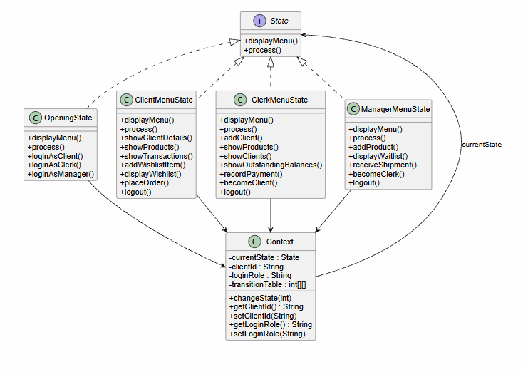

The FSM Interface Class Diagram shows the classes that make up the finite state machine implementation for the warehouse user interface. The Context class manages the current state and stores information needed to control transitions, such as the active client and login role. The State interface defines the common behavior that all states must implement. The four concrete state classes, OpeningState, ClientMenuState, ClerkMenuState, and ManagerMenuState, provide the functionality required for each user role and implement the operations specified in the assignment requirements.

FSM State Transition Diagram: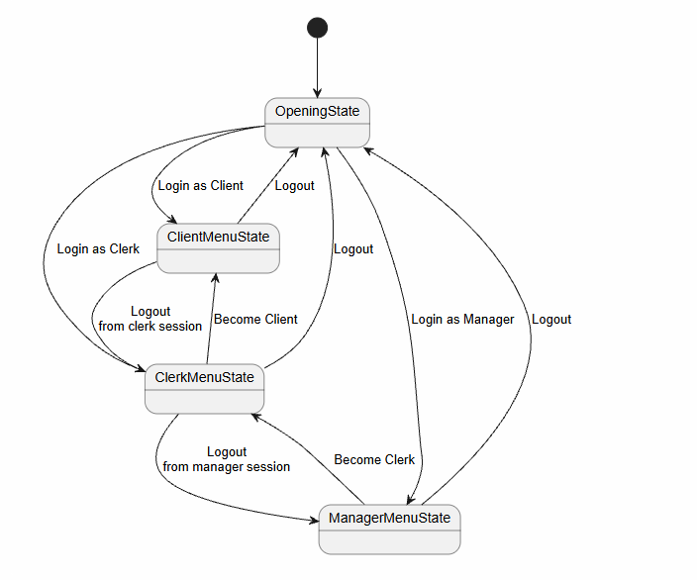

The State Transition Diagram shows how users move between the four FSM states. Users begin in the OpeningState and may transition to the ClientMenuState, ClerkMenuState, or ManagerMenuState based on the selected login option. A clerk may transition to the ClientMenuState through the Become Client operation, and a manager may transition to the ClerkMenuState through the Become Clerk operation. Logout operations return the user either to the OpeningState or to the user's previous role, as determined by the information stored in the Context object. This allows the FSM to properly route users back to the appropriate state while maintaining a deterministic state transition model

